IPv6 was developed by Internet Engineering Task Force (IETF) to deal with the problem of IPv4 exhaustion. IPv6 is a 128-bits address having an address space of 2128, which is way bigger than IPv4. IPv6 use Hexa-Decimal format separated by colon (:) .

**Components in Address format :**

1. There are 8 groups and each group represents 2 Bytes (16-bits).
2. Each Hex-Digit is of 4 bits (1 nibble)
3. Delimiter used – colon (:)

## Addressing methods

***1. Unicast Address***  
Unicast Address identifies a single network interface. A packet sent to a unicast address is delivered to the interface identified by that address.   
  
***2. Multicast Address***  
[Multicast](https://www.geeksforgeeks.org/multicasting-in-computer-network/) Address is used by multiple hosts, called as **groups**, acquires a multicast destination address. These hosts need not be geographically together. If any packet is sent to this multicast address, it will be distributed to all interfaces corresponding to that multicast address. And every node is configured in the same way. In simple words, one data packet is sent to multiple destinations simultaneously.  
  
***3. Anycast Address***  
Anycast Address is assigned to a group of interfaces. Any packet sent to an anycast address will be delivered to only one member interface (mostly nearest host possible).   
  
**Note:** Broadcast is not defined in IPv6.

**Types of IPv6 address:**  
We have 128 bits in IPv6 address but by looking at the first few bits we can identify what type of address it is. 

| **Prefix** | **Allocation** | **Fraction of Address Space** |
| --- | --- | --- |
| 0000 0000 | Reserved | 1/256 |
| 0000 0001 | Unassigned (UA) | 1/256 |
| 0000 001 | Reserved for NSAP | 1/128 |
| 0000 01 | UA | 1/64 |
| 0000 1 | UA | 1/32 |
| 0001 | UA | 1/16 |
| 001 | Global Unicast | 1/8 |
| 010 | UA | 1/8 |
| 011 | UA | 1/8 |
| 100 | UA | 1/8 |
| 101 | UA | 1/8 |
| 110 | UA | 1/8 |
| 1110 | UA | 1/16 |
| 1111 0 | UA | 1/32 |
| 1111 10 | UA | 1/64 |
| 1111 110 | UA | 1/128 |
| 1111 1110 0 | UA | 1/512 |
| 1111 1110 10 | Link-Local Unicast Addresses | 1/1024 |
| 1111 1110 11 | Site-Local Unicast Addresses | 1/1024 |
| 1111 1111 | Multicast Address | 1/256 |

**Note:**In IPv6, all 0’s and all 1’s can be assigned to any host, there is not any restriction like IPv4.

**Provider-based Unicast address :**   
These are used for global communication. 

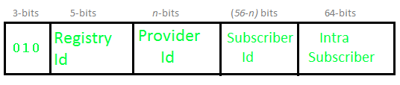  
The First 3 bits identify it as of this type.   
**Registry Id (5-bits):** Registry Id identifies the region to which it belongs. Out of 32 (i.e. 2^5), only 4 registry IDs are being used.

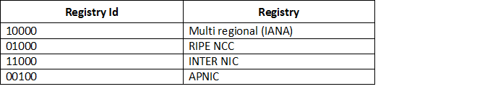

**Provider Id:** Depending on the number of service providers that operate under a region, certain bits will be allocated to the Provider Id field. This field need not be fixed. Let’s say if Provider Id = 10 bits then Subscriber Id will be 56 – 10 = 46 bits.   
**Subscriber Id:** After Provider Id is fixed, the remaining part can be used by ISP as a normal IP address.   
**Intra Subscriber:** This part can be modified as per the need of the organization that is using the service.   
  
**Geography based Unicast address :** 

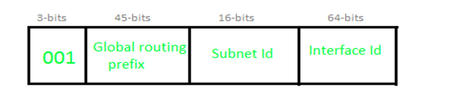

**Global routing prefix:** Global routing prefix contains all the details of Latitude and Longitude. As of now, it is not being used. In Geography-based Unicast address routing will be based on location.   
**Interface Id:** In IPv6, instead of using Host Id, we use the term Interface Id.   
  
**Some special addresses:**   
**Unspecified**

### https://media.geeksforgeeks.org/wp-content/uploads/IP_v6_6.png ****Loopback****

### https://media.geeksforgeeks.org/wp-content/uploads/IP_v6_7.png ****IPv4 Compatible****

### https://media.geeksforgeeks.org/wp-content/uploads/IP_v6_8.png ****IPv4 mapped****

#### https://media.geeksforgeeks.org/wp-content/uploads/IP_v6_9.png

Local Unicast Addresses :   
These are of two types: ***Link-local*** and ***Site-Local***

### ****1. Link-local address:****

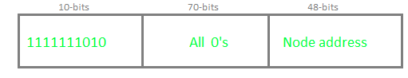

A link-local address is used for addressing a single link. It can also be used to communicate with nodes on the same link. The link-local address always begins with 1111111010 (i.e. FE80). The router will not forward any packet with Link-local address. 

### ****2. Site local address:****   https://media.geeksforgeeks.org/wp-content/uploads/IP_v6_11.png

Site local addresses are equivalent to a private IP address in IPv4. Likely, some address space is reserved, which can only be routed within an organization. The first 10-bits are set to 1111111011, which is why Site local addresses always begin with FEC0. The following 32 bits are Subnet IDs, which can be used to create a subnet within the organization. The node address is used to uniquely identify the link; therefore, we use a 48-bits MAC address here.

A link-local address is an IPv6 unicast address that can be automatically configured on any interface that uses the link-local prefix FE80::/10 (1111 1110 10) and the interface identifier in the modified EUI-64 format. Link-local addresses are not necessarily bound to the MAC address (configured in a EUI-64 format). Link-local addresses can also be manually configured in the FE80::/10 format with the[ipv6 address link-local](https://www.cisco.com/en/US/docs/ios/ipv6/command/reference/ipv6_05.html#wp2320779)command.

These addresses refer only to a particular physical link and are used for addresses on a single link for purposes such as automatic address configuration and neighbor discovery protocol. Link-local addresses can be used to reach the neighboring nodes attached to the same link. The nodes do not need a globally unique address to communicate. Routers do not forward datagram with link-local addresses. IPv6 routers must not forward packets that have link-local source or destination addresses to other links. All IPv6 enabled interfaces have a link-local unicast address

Routing Information Protocol (RIP) is a dynamic routing protocol that applies hop count as a routing metric to find the best path between source and destination networks.

RIPng stands for**Routing Information Protocol Next Generation**. Plain distance-vector protocol utilizing [UDP](https://www.geeksforgeeks.org/user-datagram-protocol-udp/) as its transport protocol using port number **521** instead of 520 (to avoid conflict with the existing RIPv1 & RIPv2).

RIPng is intended to allow routers to exchange information for computing routes through an IPv6-based network. RIPng is a distance vector protocol,

Each router that implements RIPng is assumed to have a routing table. This table has one entry for every destination that is reachable throughout the system operating RIPng. Each entry contains at least the following information:

- The IPv6 prefix of the destination.

- A metric, which represents the total cost of getting a datagram from the router to that destination. This metric is the sum of the costs associated with the networks that would be traversed to get to the destination.

- The IPv6 address of the next router along the path to the destination (i.e., the next hop). If the destination is on one of the directly-connected networks, this item is not needed.

- A flag to indicate that information about the route has changed recently. This will be referred to as the "route change flag."

- Various timers associated with the route.